* Basic JOINs
  + To combine data across tables, you need to include a JOIN clause in your SQL SELECT statement
    - Join is used to fetch data from 2 tables that have at least one column in common
  + There are actually 4 different types of JOIN clauses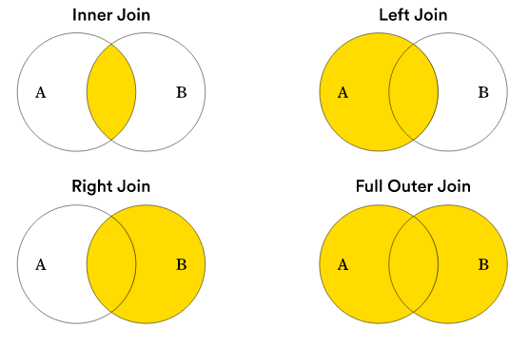
    - Inner Join
      * The INNER JOIN clause returns only rows where there is a match in both tables
      * For example:

SELECT *

FROM employees

INNER JOIN salaries

ON employees.id = salaries.id

* + - * + After the FROM clause, we have 2 new clauses:

INNER JOIN, which takes a table name

ON, which takes two column names separated by an equals sign

NOTE that the column name is preceded by the table name in the ON clause, so the full entry for each is “employees.id” and “salaries.id”

* + - * + The ON clause maps the relationship between the two tables

The first part of this clause says that the “id” field in the “employees” table…

ON employees.id

…can be joined against…

ON employees.id =

…the “id” field in the “salaries” table

ON employees.id = salaries.id;

* + - * + These two fields are referred to as JOIN keys, and either one can be written first

ON employees.id = salaries.id;

* + - * If the two fields had different names but their content was the same, you could still join them in an ON clause:

SELECT *

FROM employees

INNER JOIN salaries

ON employees.id = salaries.employee_id;

* + - Left Join
      * A LEFT JOIN returns all the values from the left table, plus matched values from the right table, or “null” in case of no match
    - Right Join
      * A RIGHT JOIN returns all the values from the right table, plus matched values from the left table, or “null” in case of no match
    - Full Outer Join
  + To review, the left table is the one that is written before the JOIN keyword in your query. The right table is the one written after the JOIN keyword
    - It is up to you to decide which is the left table and which is the right
  + INNER JOIN and FULL OUTTER JOIN are not affected by the order of the tables in y our query; they return the same results either way
    - INNER JOIN excludes any records that don’t have a match on both sides
    - FULL OUTTER JOIN includes all records, regardless of whether or not there is a match